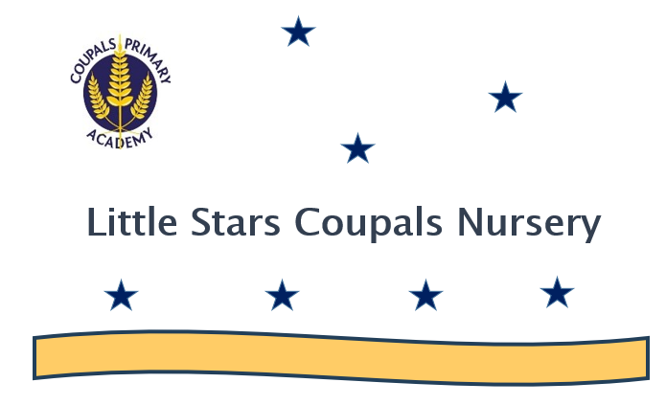

Parent Information Booklet 2025-2026

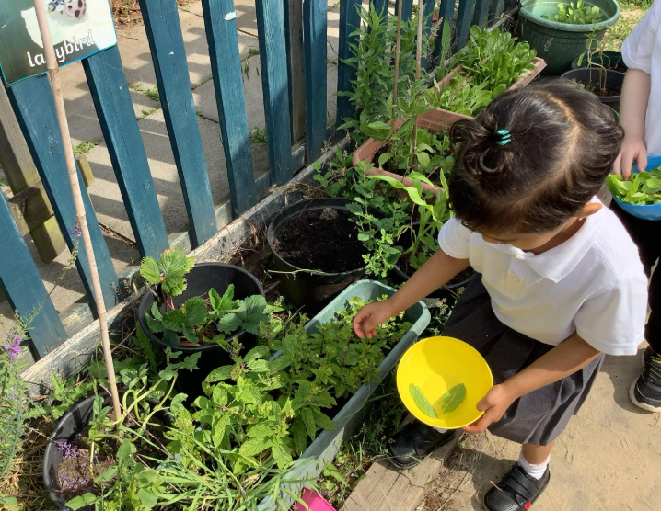

Welcome to ‘Little Stars Coupals’. We are part of Coupals Primary Academy and are a vital part of the Early Years Foundation Stage. We work very closely with the whole school, particularly Reception, as well as with other schools in the Unity Schools Partnership. Our aim is to introduce and settle your child happily into an educational environment, to begin their learning journey and provide them with firm learning foundations to ensure a seamless transition into school. This booklet is designed to provide you with the information you may need and to give some details about what the Early Years Foundation Stage looks like at ‘Little Stars Coupals’.

What is the EYFS Framework?
The EYFS Framework explains how and what your child will be learning to support their healthy development from the age of 0-5 Years. This framework continues until the end of their time in Reception.
Your child will be learning skills, acquiring new knowledge and demonstrating their understanding through 7 areas of learning and development. Children should mostly develop the 3 Prime Areas first, which provides the foundation of success in the Specific Areas of Learning.

PRIME AREAS
Communication and  Language |  | Personal, Social and Emotional Development |  | Physical Development
- Listening, Attention and Understanding  - Speaking |  | - Self-regulation  - Managing self  - Relationships |  | - Gross motor skills  - Fine motor skills
SPECIFIC AREAS
Literacy | Mathematics |  | Understanding the World |  | Expressive Arts
- Comprehension  - Word reading  - Writing | - Number  - Numerical patterns |  | - Past and Present  - People, Culture and Communities  - The Natural World |  | - Creating with materials  - Being Imaginative and Expressive

Underpinning the Early Years Framework are the Characteristics of Effective Learning:
- Playing and exploring (engagement)
- Active Learning (motivation)
- Creating and thinking critically (thinking)
The Characteristics of Effective Learning describe behaviours children use to learn. Children learn best when approaching activities with curiosity, energy and enthusiasm. We know these abilities create strong learners that will support maximum progress throughout their learning journey.

What learning looks like at Little Stars Coupals
Our EYFS Curriculum involves a balance of adult-initiated, adult-led and child-led learning. Children are explicitly taught skills and knowledge required to achieve success in the Nursery, but the curriculum also enables us to follow children’s interest and curiosity. Learning occurs both indoors and outside the classroom.
Adult Explicit Teaching – Lessons planned by the adult to develop skills and knowledge through whole class teaching and guided groups.
Adult-Led Learning – Activities set up by the adults for children to explore and discover.
Child-Led Learning – The child chooses their own learning within

CUSP Early Foundations

All children will receive support to develop knowledge and learning foundations through a highly ambitious curriculum provided by Unity Schools Partnership, CUSP Early Foundations. It focuses on the holistic development of a child’s social, emotional, cognitive and physical needs in order to build a solid and broad foundation for lifelong learning and well-being. This curriculum is presented in three parts :
● Foundational Knowledge - What children should know and be able to do throughout the EYFS and how this will support their development and prepare them for success in Key Stage 1 and beyond.
● Opportunities and Experiences - How this foundational knowledge can be learnt through play and through guided activities that will allow children to explore, experiment with and think hard about new and important concepts.
● Structured Story Time - Carefully selected core texts that will introduce key language, ideas and themes that children will need to access the foundational knowledge, built into a framework that uses effective literacy instruction.

Early Literacy and Maths
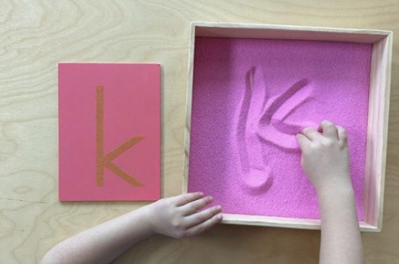
In Nursery, there is a strong focus on the teaching of Phase One Phonics. This involves teaching the children to ‘tune into sounds’; environmental and instrumental sound discrimination, voice sounds, body percussion, alliteration, rhythm and rhyme, oral blending and segmenting sounds in words.
Children will explore and discuss a range of sounds through fun games and activities; listening walks, junk band, syllable clapping, music and movement, singing, listening to and joining in with stories and rhymes. Throughout each day children will be ‘bumping into phonics’ and learning to apply the skills they have learned.
Children who are secure in ‘Phase One’ phonics tend to make the most progress in reading and writing in Reception and beyond.
We introduce ‘Sounds Write’ in the summer term to children who will be beginning Reception in the following term, to support our phonics teaching and this is continued in Reception and beyond.
Resources are commercially available which enables you as parents and carers to support your child with literacy at home.
Throughout the school, we are using ‘Kinetic Letters’ to develop children’s pencil grip and letter formation. To support this, we encourage the children within the Early Years to use letter pattern formations, making marks in sensory media as well as air-writing in our ‘Squiggle While You Wiggle’ sessions.
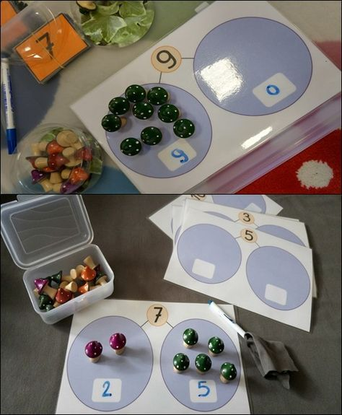
In Mathematics, children learn to recite numbers in order and are encouraged to use counting, number names and numerical language in their play. They learn to compare quantities and represent numbers on their fingers and with pictures and objects. We teach them to recognise numbers, become aware of numbers in their environment and to demonstrate 1:1 finger correspondence when counting.
Our focus is to provide children with a very deep and broad understanding of numbers using a range of strategies and in a variety of contexts.
Children are taught to understand and use positional language, to develop an interest in shape through playing with shapes and puzzles, finding and talking about shapes and using words like ‘flat’, ‘straight’, ‘curved’ and ‘round’ to describe them. They learn to categorise objects according to shape and size and learn vocabulary linked to length, height, weight and capacity.
They also learn to recognise and create patterns. You can support your child by making the most of mathematical learning opportunities which arise in everyday life. For example, looking at door numbers on your walk to school, counting stairs or recognising shapes around the house.

Library
We have an amazing library at Coupals Primary Academy, which nursery have the opportunity to visit regularly. We also visit the local library in Haverhill and have various members of staff that read their favourite stories to the children across the year called ‘Secret Readers’. Throughout the year, our topics are based around stories and information books and story time is an important part of our daily routine.
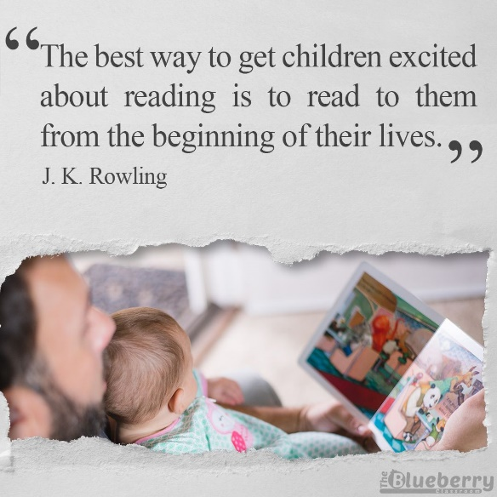
We foster a love of books and reading in Nursery. We have a lovely cosy classroom library full of exciting and engaging books. We also promote the love of reading through our Dream Reads. There are 40 Dream Read Books, which have been carefully selected by staff to promote a love of reading. These books are sent home each week for parents and children to share and enjoy.
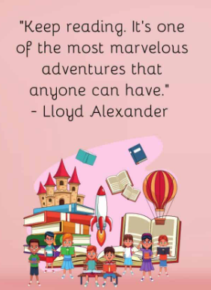

A Typical Day in Nursery
In Nursery, our routine is the same each day. Each session begins with 5-10 minutes of DEAR (Drop Everything and Read) time, followed by welcome and registration. Each session has a different focus e.g. literacy. We create a visual timetable with the children so they know the plan for the day.

8:45am Doors open to the Nursery. Start of the day. Parents are encouraged to drop their child off at the Nursery Classroom where a teacher will great them
8.50am-9.00am DEAR/Register/Maths Moment (Calendar Time)
9:00am – 9.15am Physical Learning
9:15am -10:15am Continuous provision (Discovery Time)
10:15am-10:30am Whole Class Snack
10:30am-10:45am Phonics/Maths Input
10:45am – 11.20am Continuous provision (Discovery Time)
11:20am – 11:35am Structured Story Time/Foundational Knowledge
11:35am- 11:45am Singing Songs/Home Time/Afternoon Children Arrive/Washing Hands
11:45am- 1:00pm Lunch
1.00pm 1.10pm Registration and Mindfulness
1.10pm-1.20pm Phonics/Maths Input
1.20pm- 2:30pm Continuous provision (Discovery Time) and Snack
2:30pm-2:45pm Getting Ready for home time/Singing Songs/End of the Day Story
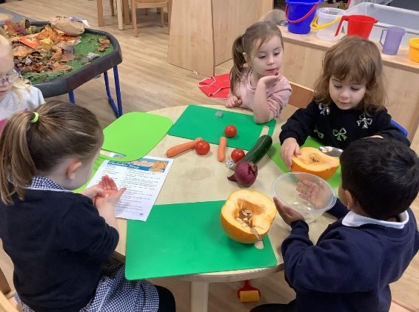
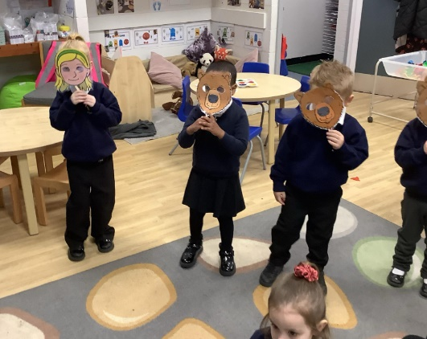
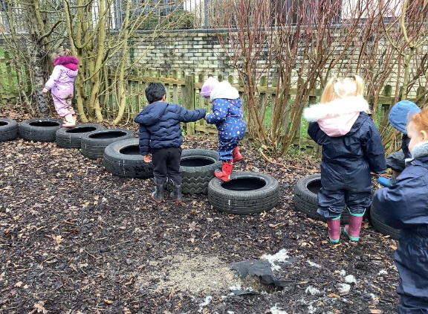

Outdoor Learning
Outdoor play is beneficial for children beyond the physical activity it provides. It helps them socialise, understand their bodies better, engage in imaginative play and enjoy the outdoors. We prioritise outdoor play at every opportunity. Children have the choice to play where they choose (indoors or outdoors). We carefully plan activities for the outdoor learning environment every week the same as the inside learning environment. We value the importance of outdoor play at every opportunity. In our setting…
- Children have access to the outside area throughout the day during discovery time (children choosing time)
- Children will be outside in ALL TYPES OF WEATHER
- All children MUST have a pair of wellies brought to school in the first week, which will stay at school for the rest of the year. If your child changes shoe size please bring in another pair of wellies
- Outside areas include: mud kitchen, building and construction, maths, mark making, art and creative, physical, gross motor, sand, water, bikes, music, performance, role play and dress up
- Same as the indoor area the outside area and activities change often and are lead by the children’s interests and learning is extended through high quality interactions with staff
- Your child will get dirty, this is part of learning- please ensure they always have spare clothes
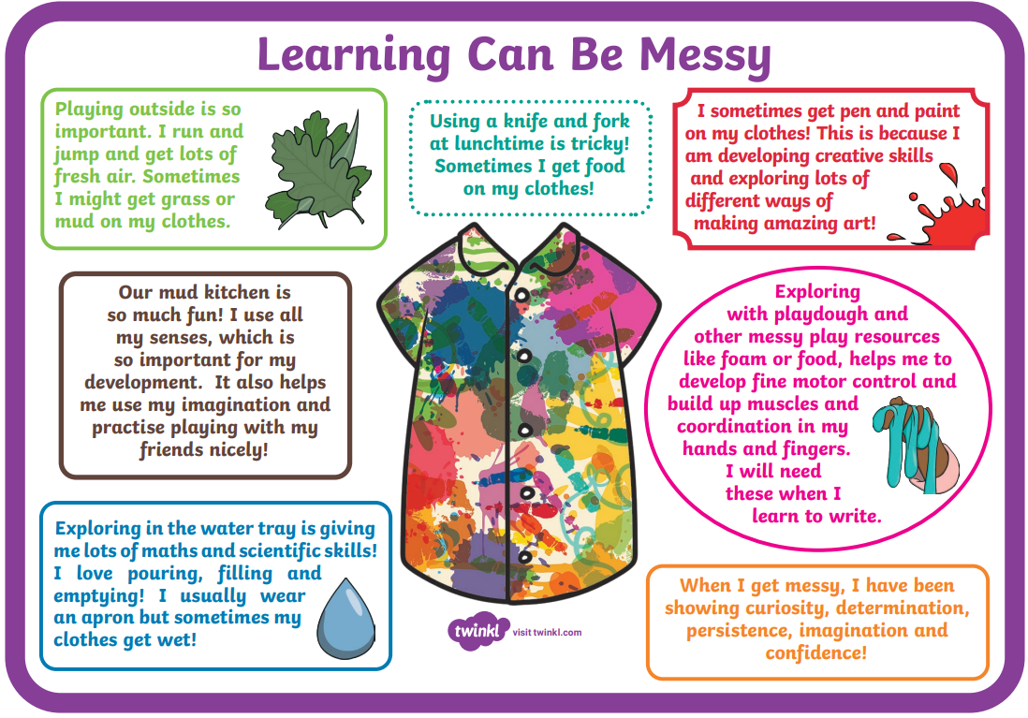

Golden Rules
At Little Stars, we support children in line with our ethos and values of the school.
Here are our Golden Rules – these are taught through the Golden Rules stories and are used to support a positive ethos in our nurseries:
We are gentle
We don’t hurt others
We are kind and helpful
We don’t hurt anybody’s feelings
We listen
We don’t interrupt
We are honest
We don’t cover up the truth
We work hard
We don’t waste our own or others’ time
We look after property
We don’t waste or damage property


Growth Mindset
We use the Characteristics of Effective Learning from the EYFS Statutory Guidance to teach and encourage Growth Mindset Thinking. Growth Mindset Thinking can result in:
● A love for learning and self-improvement
● A willingness to work for positive results
● A desire to take on new challenges
● The ability to learn from mistakes
● Emotional resilience
● Self-motivation
In Nursery, we encourage children to take on new challenges, to keep practising and not give up when they find something challenging. We praise their effort and share their achievements.

Our Values
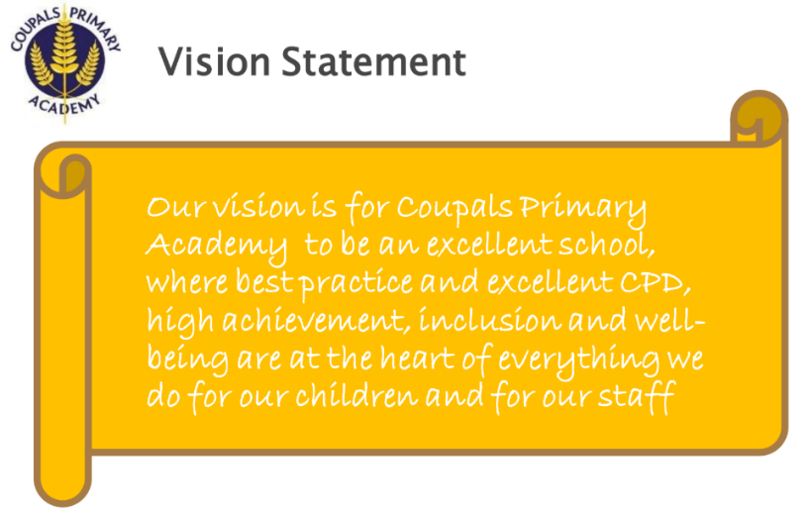
Determination
Readiness
Integrity
Versatility
Empathy

Show and Tell
All children have the opportunity to bring home the ‘Marvellous Me’ bag; they can put up to 5 items into the bag which they then talk about with the class. Items might include their favourite story book, a photo of their pet or family, a favourite toy, a special moment from a day out, etc. Toys should not be brought to school on other occasions as they can be easily lost or broken.

Working in partnership
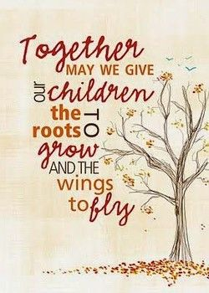
Research shows that involving parents and carers in their children’s learning is the most important factor in enabling children to do well. In EYFS we like to build positive relationships with all our families to ensure the best start to our children’s journey in school. We expect all parents and carers to be fully involved in their child’s learning and support additional learning that may need to take place at home, such as reading and sharing stories with your child.

Communication

Regular communication is vital between school and families. We communicate via the following:
- Class Dojo – To share whole class learning, weekly learning update, individual wow moments, school messages from all teachers, and a private message function to communicate directly with school staff.
- School Website
- School newsletters
- Class/Curriculum newsletters
- Parents evening
- End of term / year reports.
- Face to face during drop off and collection times.
- Stay and Play sessions
- Parent Support Information Sessions- these sessions will take place across the year so all parents know how to support their child’s learning at home


Follow us on Facebook! Coupals Primary Academy

School Uniform
Coupals jumpers and cardigans can be bought with the school logo on from Mapac School Wear at the following address www.mapac.com/education/parents/uniform/coupalsprimaryacademy
All other items of uniform can be found in local supermarkets and stores.
Please note all children are required to have a Coupals branded jumper or cardigan from September 2025.


Our Little Stars Coupals Uniform:
Autumn / Winter / Summer
- Blue school jumper or cardigan (with logo)
- Plain black jogging bottoms or leggings (no logos)
- Plain black PE shorts (in warmer weather) (no logos)
- White polo shirt (no logos)
- White, grey or black plain socks
- Trainers

PLEASE ENSURE ALL UNIFORM, INCLUDING SHOES and SOCKS ARE NAMED
Jewellery is not permissible. Nail varnish is not permitted. Children should not have clipped patterns in their hair.
Blue book bags are optional; however, we strongly suggest to by a book bag so that children can bring home their wonderful creations and their Dream Book each week.

Wrap Around Care
Our Nursery Session finishes each day at 2:45pm. We do provide an additional wrap around care for children till 3:25pm at a cost of £4.50 per session. The Wrap Around Care is run by the Nursery staff, which is for the ease for the children and enables them to have a familiar face. Wrap Around Care takes place in the Nursery Classroom. If you are interested in this provision, please ask the office team at the front office, who will be able to help you. The children do need to be booked into Wrap Around Care as it is run on adult to child ratio. Bookings are made in advance via the office and are payable half a term in advance.


School Lunchtime and Snacks
All children are provided with a fruit or vegetable snack and a drink of water or milk during each Nursery session. If your child would like to bring in their own fruit or healthy snack they are welcome to.
Children have access to water throughout the day.
They are supported by an adult with hand washing and table expectations including manners.
Those children who stay for lunch MUST bring their own packed lunch from home. All children eat their lunch in the Nursery Room and are accompanied by a member of staff.
They are expected to eat independently and demonstrate good table manners. Water is provided every lunch time and children have access to their water bottles all day. Please note during the day drink bottles must contain only water.

Please do not send nuts or any products containing nuts into school. We encourage children to bring a healthy lunch to school. Packed lunches should be in a container/lunchbox with your child's name marked clearly on it. Please ensure anything that is cut up if required and your child can open their own containers and food.
We have a new policy that relates to the new guidance from the DFE: Our Food and Nutrition Policy can be seen on our website.
Packed lunches should not include:
- Confectionery such as chocolate bars, chocolate-coated biscuits, sweets and chewing gum.
- Fizzy or sugary drinks.
- No chocolate spread (due to the possibility of containing nuts)
.

Attendance

Being in Nursery is important to your child’s achievement, wellbeing, and wider development. Research shows that high levels of attendance and punctuality improve outcomes for children.
Please see key times below:
8:40am – Nursery doors open and registration time
8:45am – Registration closed
8:45am – onwards – children will be marked as late and will need to sign into school via the school office.
If your child is unwell, please call the school office by 9am.
Our Nursery Day ends at 2:45pm for all children. If your child is registered for Wrap Around Care this finishes at 3:15pm. Please ensure you are on time to collect your child at the end of the day. If for any reason you are running late please phone the school office so that they can let the team know. If you are persistently late you will incur a late charge as per the admission policy.
Attendance of all children is monitored weekly. As a school, we are supportive of families and work with you to ensure the children have good attendance.

Drop off and Collection
- Drop off is at the Nursery Gate at 8:45am. The morning session finishes at 11:45am and the afternoon sessions begins at 11:45am.
- The Nursery day ends at 2:45pm, pick up will be at the Nursery Gate. Staff willl release your child to you at the end of the session.
- Please ensure you are not on your phone at drop off or collection so that staff can speak to you if needed and release your child. Please note if you are on your phone we will not release your child.
- If someone else other than the usual person is collecting your child please let Nursery staff and the office know- we may ask for ID or a password if we do not know who you are.
- Please be patient with staff whilst they get to know your faces, it may take us a few weeks to get to know you.
- Drop offs can be tricky, we kindly ask that you drop and go as quick as you can, we will settle your child, provide extra cuddles and reassurance when they are unsettled. If for any reason they do not settle we will ring you.
- Please ensure you are on time to collect your child- if you are running late please phone the office so that the team knows and will hold your child till you arrive.
- Please note that if you persistently late you will be billed late fees as per our admissions policy.

What does your child need each day?
Here are some things that your child will need to bring to Nursery each day:-
- A suitable coat – Nursery have access to outside throughout the day and in all weathers. Please ensure your child comes prepared for this.
- A pair of Wellington Boots – Nursery have access to outside throughout the day and in all weathers. Please ensure your child has a pair of NAMED wellies that will stay in Nursery all year. If your child’s shoe size changes please ensure you bring in another pair of wellies.
- A book bag (if possible) – we will put letters being sent home in here, along with their library book and any pictures, paintings or writing they have done.
- Water bottle (no squash or fizzy), packed lunch if staying for lunch.
- A complete change of clothes – if you think your child might need changing then it is really helpful to us if they have a couple of spare set of clothes in school.
- Spare knickers or pants, wet wipes, pull-ups and nappy bags if your child is likely to have an accident.
- Hat- Nursery children will be outside in all weather please ensure they have a summer and winter hat brought in each time.

Medical
- Any sickness, diarrhoea, must be followed by 48 hours absence.
- Any absence requires an email or a telephone call to the office explaining why they are absent by 9am.
- Head lice and worms are common in children. Please check regularly and treat as recommended and let staff know so they can clean as necessary. Children must have long hair tied up.
- Any medicines/creams can only be administered by prior arrangement and appropriate forms need to be filled out at the front office- please do not leave medic ation in your child’s bag.
- All staff in Nursery are first aid trained. If your child takes a tumble in the day we will send home an accident form and let you know on the gate at handover.
- If your child is hurt or we are concerned about your child we will always ring you.
- Accidents do happen, children will fall over but we will always be there for a cuddle and pick them back up.
- If there are medical appointments please let the Nursery Team know and please provide any information given at the medical appoitnment to staff so they can fullt support your child once they are in Nursery.

Toileting/Independence
Parents and Carers play a key role in promoting indepdence and teaching their children skills at home. Preparing and supporting your child with indepedance supports their confidence and leanring at school. If your child currently has a dummy when they begin Nursery we strongly recommend to stop using this and please do not bring your child to Nursery wearing a dummy. Using dummies at this age with children can significantly impact their teeth and their speech and langauge development.

We expect your child to be toilet trained before starting Nursery. However, if your child is not secure in this area of development then we will work in partnership with you to ensure they achieve this important milestone as quickly as possible.
If your child is not quite ready to wear pants or knickers then we prefer them to wear a pull-up as opposed to a nappy. This makes it easier for them to begin to use the toilet at Nursery and develop independence.
It is essential that you as the parent provide enough spare pull-ups,
wet-wipes, disposal bags, knickers/pants and spare clothes for each session. For those children still wearing pull-ups or regularly soiling, we will prepare an Individual Health Care Plan. We will work with you to agree some strategies for toilet training to follow at home and at Nursery. You will be ask ed to read and agree to this plan by signing it.

We look forward to welcoming your child to Little Stars Coupals Nursery
