

Friday 6th June, 2025

Dear Parents and Carers,

It has been fantastic seeing the children return from the May half-term break with such optimism and confidence. We are incredibly proud of how they have returned and the DRIVE they have demonstrated towards their learning.

Thank you to parents and carers for completing the Trust Survey. We really value your feedback. We are delighted to share the ‘You Said…We will do…’ document below identifying the strengths and next steps moving forward.

Next week, we have two exciting Enrichments for the children. The Nursery Class are going to Boydell’s Farm on Wednesday 11th June to look at the animals. Secondly, the EYFS children are going to Audley End on Friday 13th June. Please can we ask that if there are any outstanding payments to ensure these are paid on Arbor prior to the trip.

Please can I remind parents to ask their child to come in to school wearing the correct uniform. I appreciate that we are coming close to the end of the academic year, but we are really trying to DRIVE high expectations of uniform and we would welcome your support with this. Should you need any support or if you have noticed that an item of your child’s uniform is missing, please do speak to the office at the beginning or end of the school day to see if it is in our lost property.

Additionally, please see a reminder of the Sports Days and timings:

Monday 23rd June – EYFS 9:30-11:30am
Year 1 and 2 1:20-3:20pm
Tuesday 24th June – Year Three 9:30am – 11:30am
Year Four 1:20pm- 3:20pm
Wednesday 25th June – Year Five 9:30am-11:30am
Year Six 1:20pm – 3:20pm

Have a restful weekend,

Tom Wade
Head of School

CALENDAR

June
Wednesday 11th June – Nursery Class trip to Boydell’s Farm!
Friday 13th June – Whole School Non- Uniform Day for Summer Fayre
Friday 13th June – EYFS Trip Audley End Miniature Railway
Friday 20th June – Vancols Group photos of each class
Friday 20th June – Friends Summer Fayre! 3:30-5:30pm
Monday 23rd June – Thursday 26th June – Sports Days
Friday 27th June – PD Day – School Closed for pupils

July
Thursday 3rd and Friday 4th July – Year Six trip to Mersea Outdoors, Colchester
Thursday 3rd July – EYFS Tours and Induction – 2pm and 5:30pm
Friday 11th July – Reports distributed to parents
Monday 14th July -Year Six Celebration Day and Year Six leavers Disco!
Tuesday 15th July – Year Six Graduation – 9:30am
Tuesday 15th July – Year Sixes leave to go to Secondary Schools
Wednesday 16th July- Friday 18th July – Transition week
Thursday 17th July – Disco for EYFS- Year Five pupils
Friday 18th July – last day of the summer term

SEND Parent Padlet:
https://padlet.com/lkidd11/parenting-padlet-hgdrprcnhjl3ene5
Please use this link to have an explore of our new SEND Parent Padlet, which contains lots of information resources and links to provide you with support and advice. There are links to local groups, SEND resources and parenting tips.

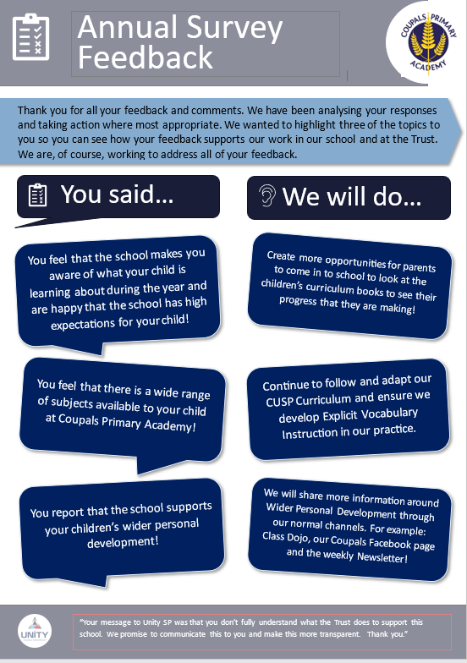

Headlines from our Parents’ Evening Parent Survey from las=te in the spring term:

Thank you everyone who contributed to this survey during parent’s evening. We are delighted with the outcomes of the survey, and are committed to working in partnership with parents as we strive to prove the best for every child in our school.
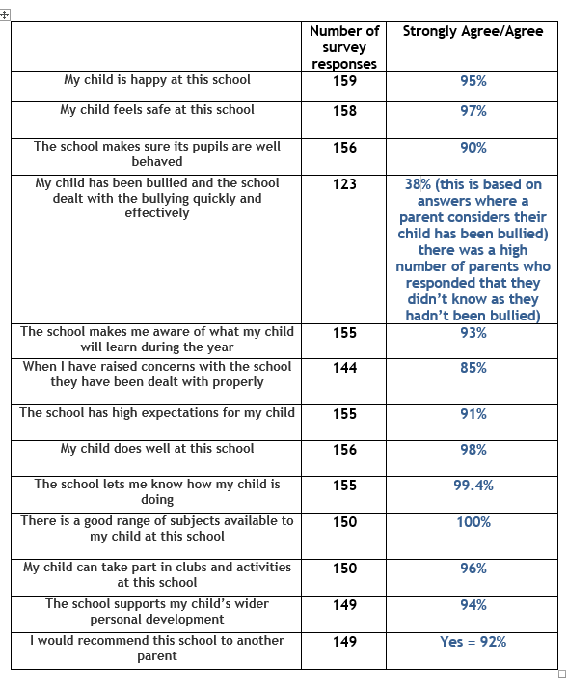

Celebration Assembly!

Please see attached the photo of the pupils who achieved certificates in assembly this week. We are incredibly proud of all of the pupils for demonstrating the DRIVE Values in all that they do! Thank you to parents who were in attendance of the assembly to share in the children’s successes this week.
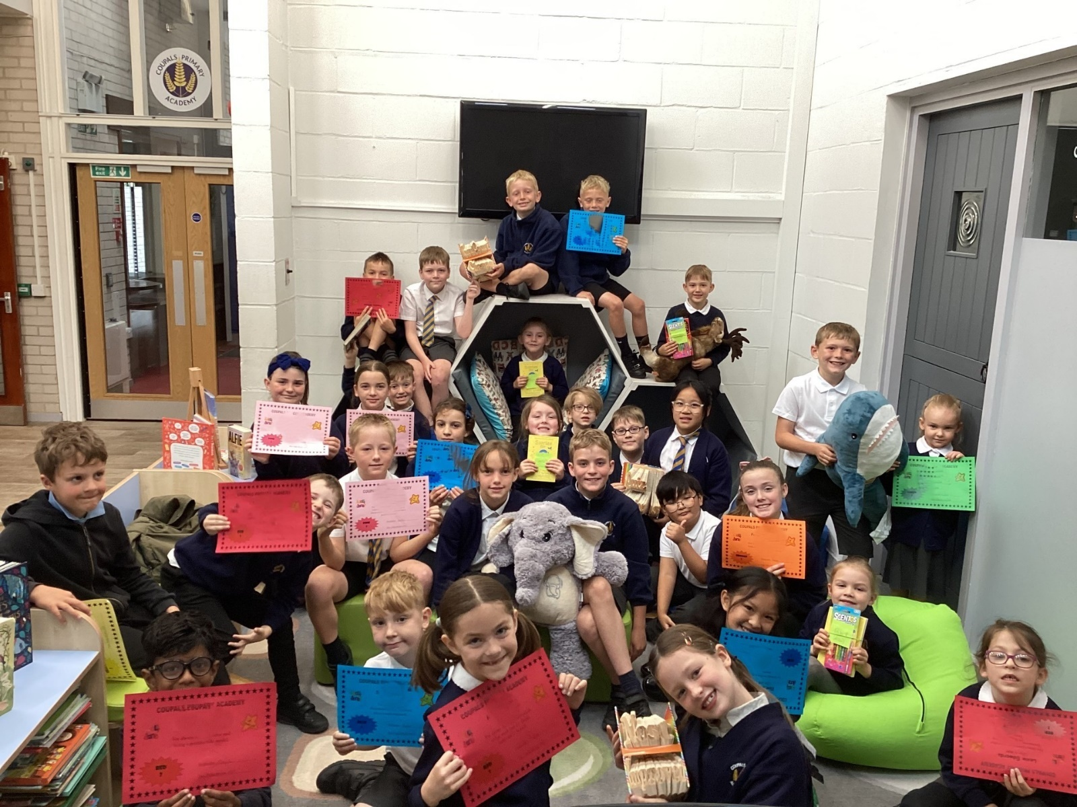

Well done to 0BP & 4GB (100%), 6CD (98.6%) and 1LP (98.1%) who were awarded the animals to spend time in their classes this week for super attendance!

NNL

The children have been learning about life cycles and we have been ready the story, The very hungry caterpillar. We have made caterpillars, threaded leaves, painted butterflies and made playdough caterpillars. We are very excited that we have caterpillars in our class to watch them transition into butterflies. We have also been enjoying taking care of our plants and are very excited that our bee stalks have grown.

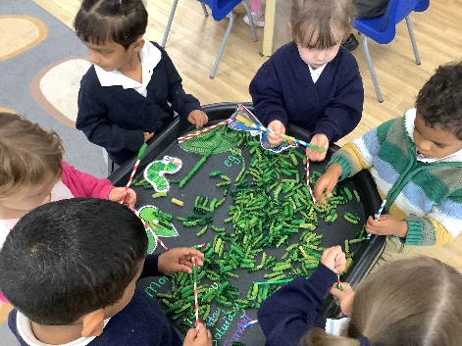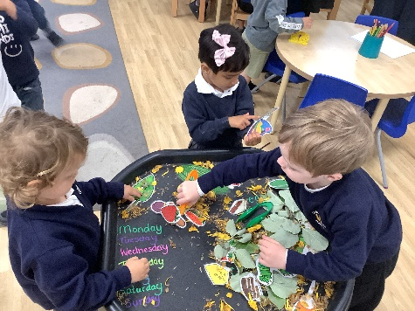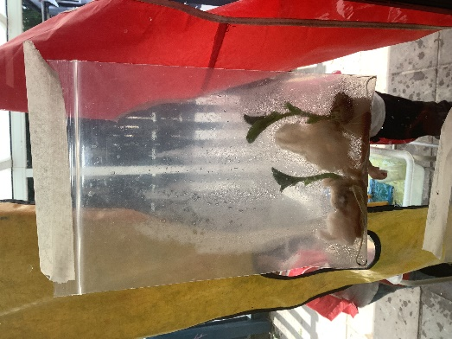

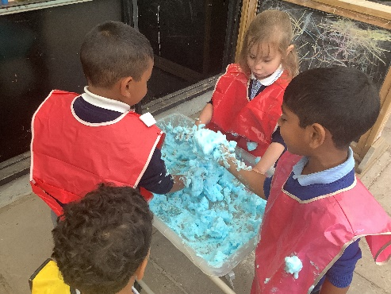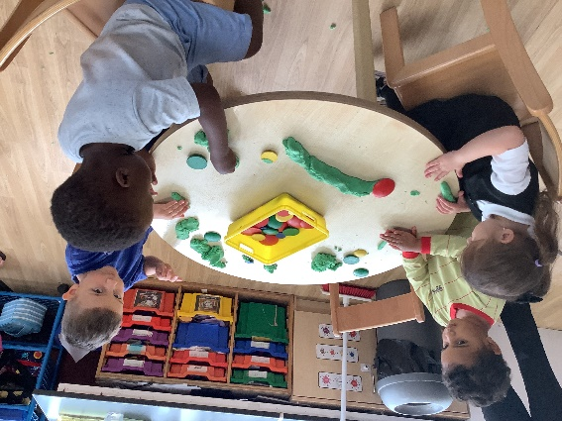

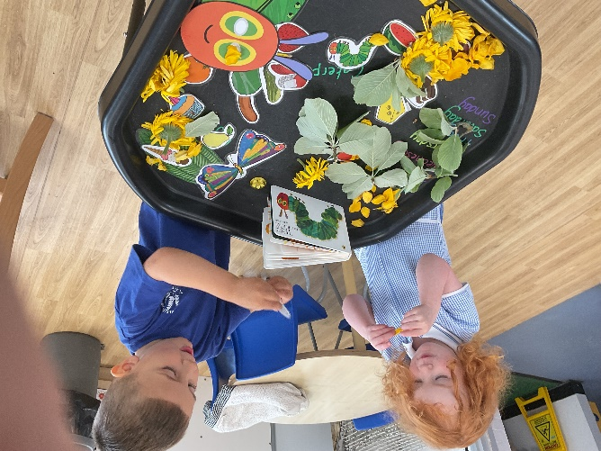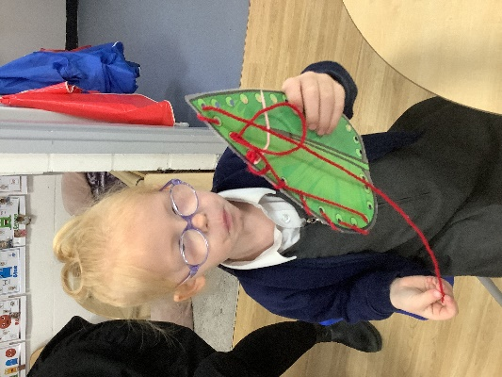

0BP
