Friday 1st March, 2024

Dear Parents and Carers,

Welcome back to you all. I hope that you all had a restful and enjoyable half-term break. It has been wonderful to welcome the children back to school this week. The children have quickly got back into learning routines and they have demonstrated both professionalism and determination in their learning.

This week, the children have been embracing ‘Keep Safe Week’. The week started with an assembly delivered by Mrs Sisson who launched the importance of ‘Keeping Safe’ and the theme of ‘No Means No’. Our Year Six pupil councillor visited Thomas Gainsborough School along with other councillors across the Trust. The Year Six pupils were visited on Thursday by St Giles Trust which proved to be an insightful session for the pupils. Amongst this, children have been immersing themselves in a menu of different activities to recognise the importance of ‘Keeping Safe’.

The I Pads are proving to be an excellent resource for the children and it is great to see that they are being used by children at home to support learning which is taking place in the class room. Please, however, can I remind parents to monitor the searches that their children are making via Smoothwall. If the children are searching for inappropriate content, then a notification is sent -via Smoothwall – to the Safeguarding team to pick up in school.

I wanted to remind everyone that next week we will be embracing World Book Day on Thursday 7th March. Please do read the message below from Miss Guiler regarding the arrangements for the day. The children are welcome to come in dressed as their favourite book characters. On Thursday 14th March, our Friends committee will also be hosting our spring term Disco. There will be more information shared by Friends regarding how to purchase tickets and the timings for the Discos.

Have a restful weekend,

Tom Wade
Head of School

CALENDAR
February
-Monday 26th February – Keep Safe Week!

March
- Thursday 7th March – World Book Day 2024!
- Thursday 14th March – Provisional date for Spring Disco!
- Tuesday 26th March – Year Four Trip to West Stow, Anglo Saxon Village
- Monday 25th March – Parents’ Evening (More information to follow)
- Tuesday 26th March – Parents’ Evening (More information to follow)
- Thursday 28th March – Spring term ends

In EYFS
As part of our RE and Understanding of the world activity, we have been learning about the season and exploring the first signs of Spring. This learning will lead on to the Spring Festival of Easter.
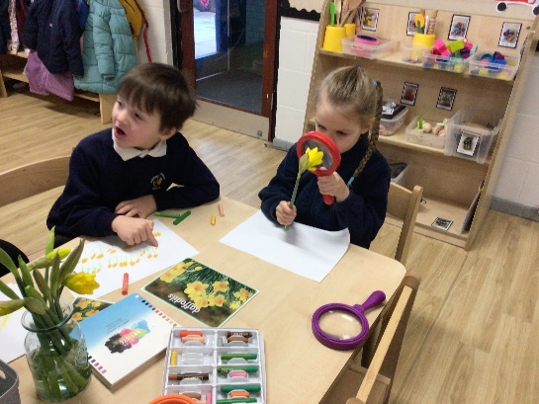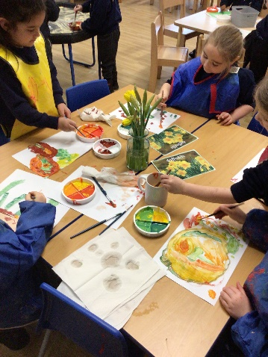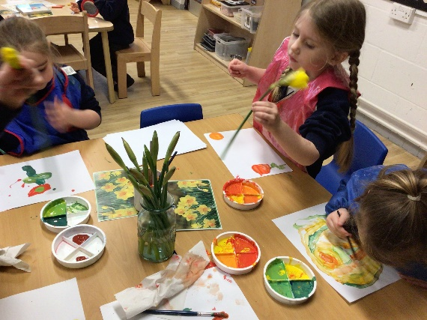

Keep Safe Week
This week, here at Coupals, we celebrated Unity Trust’s ‘Keep Safe’ Week. This year, the theme was ‘No Means No’. As part of this week, we welcomed several visitors into our school. Years 3, 4 and 5 took part in a ‘Keep Safe’ workshop led by Genine from OM Health whilst Years 1 and 2 watched a virtual session. In this session, children explored the ways we keep ourselves safe such as our online safety, our road safety and our personal safety. Years 5 and 6 took part in a knife crime prevention workshop led by St Giles which was engaging and insightful and thoroughly captivated the children. We also welcomed our local PCSOs into school who spent time talking to the children about how to keep themselves safe whilst out and about in the community. During our PSHE lessons, children started their new topic of ‘Healthy Me’. In this topic, a range of concepts are explored such as how to keep themselves safe from strangers, medicines and drugs and health and fitness.
A huge thank you and well done also goes to our Year 6 pupil who represented Coupals brilliantly at the Unity Trust Council Day. Here, they contributed to a giant piece of art, drama and music all around the theme of keeping safe.
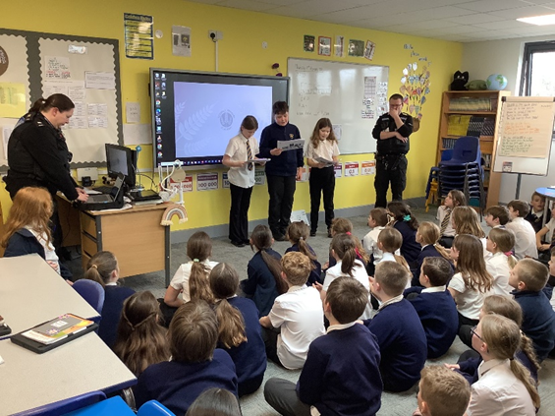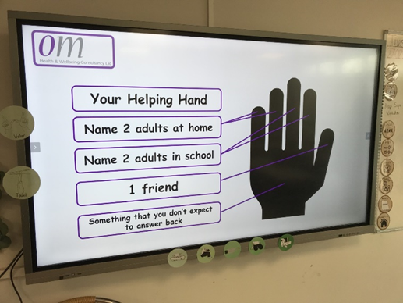
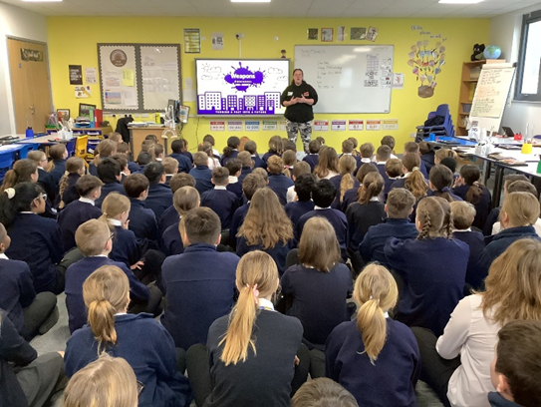

Spring Disco

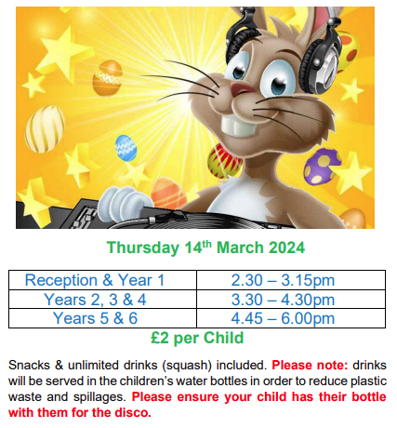

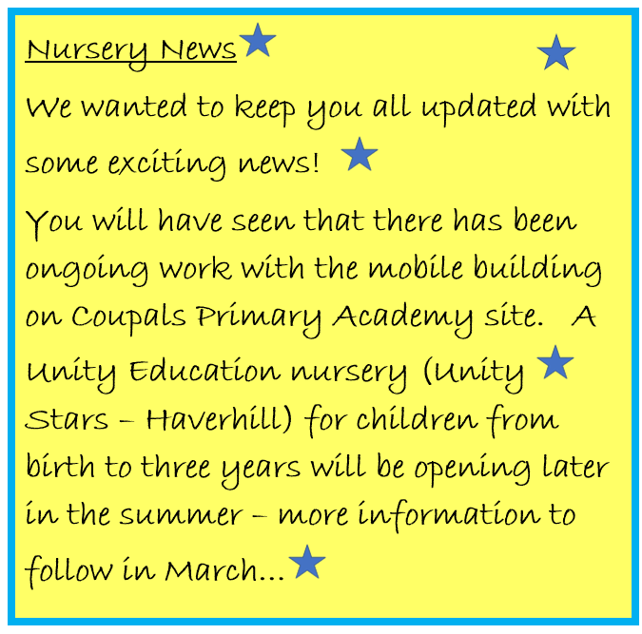

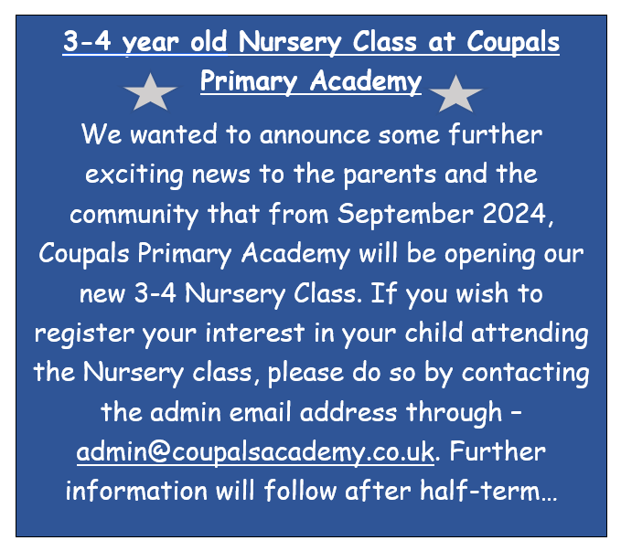

World Book Day - Thursday 7th March 2024

We are thrilled to announce that we will be celebrating World Book Day on Thursday 7th March, 2024. This special day is all about fostering a love for reading in our children and appreciating the wonderful world of books. On this day, the children are invited to come to school dressed up as their favourite book characters. We believe this will add an element of excitement to our learning environment.
We kindly request that each child brings along their own book from home to share with their classmates. This will give them an opportunity to talk about why they love their chosen book and maybe even inspire others to discover a new favourite.
Throughout the day, each class will participate in a range of fun activities related to books and reading. They will have opportunities to explore different genres, engage in creative writing exercises, and take part in quizzes and competitions. It promises to be a day filled with imagination and joy!
Thank you and we look forward to see the children all dressed up with their favourite book in hand.
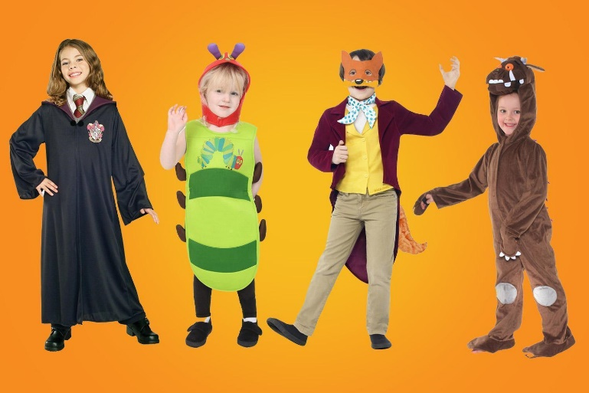
Warmest regards,
Miss Guiler

