EYFS Intent, Implementation and Impact Statement
September 2023
The Statutory framework for the Early Years Foundation Stage sets the standards for learning, development and care for children from birth to 5 years.
Intent
Our curriculum is designed to recognise children’s prior learning, both from previous settings and their experiences at home. We work in partnership with parents, carers and other settings to provide the best possible start at Coupals Academy, ensuring each individual reaches their full potential from their various starting points.
There is a strong emphasis on the Prime Areas of learning; Personal, Social and Emotional Development and Communication and Language, including Oracy. Oracy not only improves academic outcomes, but is a life skill to ensure success beyond school, in life and future employment. Our enabling environments and warm, skilful adult interactions support the children as they begin to link learning to their play and exploration right from the start.
We provide an engaging curriculum that offers a balance of Adult-Led and Adult-Initiated learning to ensure key knowledge and skills are explicitly taught. This is complemented by Child-Initiated learning, by offering extended periods of play to following children’s interests and ideas to foster a lifelong love of learning both in and outside of school.
By the end of the Reception year our intent is to ensure that all children make at least good progress from their starting points are equipped with the skills and knowledge to have a smooth transition into Year 1.
Our Drive Values:
As a whole school, these are the core values and principles which we expect all children to demonstrate.
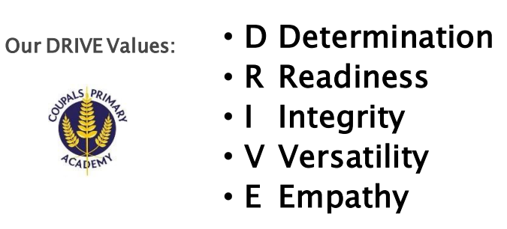

Implementation
The timetable is carefully structured so that children have directed teaching during the day. These sessions are followed by small focused group work. This means the teacher can systematically check for understanding, identify and respond to misconceptions quickly and provide real-time verbal feedback which results in a strong impact on the acquisition of new learning. The curriculum is planned for the inside and outside classrooms and equal importance is given to learning in both areas.
English / Literacy
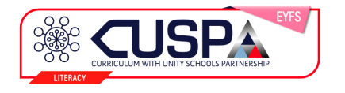
In EYFS we follow the CUSP Early Foundations, which is guided by evidence-led curriculum structures, such as retrieval and spaced retrieval practice. It is underpinned by explicit vocabulary instruction and research-focused pedagogy.
Phonics
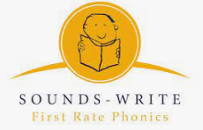
We follow the Sounds-Write programme, an approved DfE provider to ensure consistency across the school. Sounds-Write is a highly structured, cumulative, sequential, explicit and code-oriented instructional programme for teaching all children to read and spell. For further information, please refer to our Phonics Policy.
Mathematics 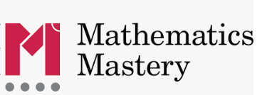
In Reception we follow the Mathematics Mastery Programme of work. High quality learning environments and meaningful interactions with adults, support children in developing mathematical thinking and discussion.

Wider Curriculum
We use the follow programmes of study to support PSHE and R.E which following through from EYFS to Y6.
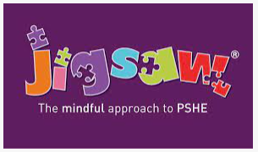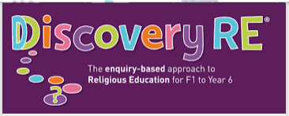
Building further on our oracy focus, children will be encouraged to employ subject specific language and terminology in foundation subjects, using Giant Knowledge notes.

Impact
Baseline:
Prior to children starting, staff spend time speaking to the child’s parents, previous settings and read previous learning journeys to gain an understanding of the whole child and where they are at. During the first half term in Nursery or Reception, all staff use ongoing assessments, observations and conversations with the child to develop a baseline assessment. This identifies each individual’s starting points in all areas so we can plan experiences to ensure progress. The following baseline assessments are also carried out.
The RBA (Statutory Reception Baseline Assessment)
This assessment focuses on ‘Language, Communication and Literacy,’ and ‘Mathematics.’ The purpose of this is to show the progress children make from Reception until the end of KS2.
Ongoing Observation:
All ongoing observations are used to inform weekly planning and identify children’s next steps. This formative assessment does not involve prolonged periods of time away from the children and excessive paper work. Practitioners draw on their knowledge of the child and their own expert professional judgements through discussions with other practitioners, photographs and physical examples such as a Phonics and Writing books.
Assessment:
Phonic assessments are carried out using phonics Tracker every half term to quickly identify pupils that are not making expected progress. Our aim is for children to ‘keep up’ rather than ‘catch up’ where possible.
Assessments are completed three times per year and shared with parents, whereby the Class Teacher updates the progress children have made. In Summer Term 2, the EYFSP is completed where teacher judge whether the child has met each of the 17 ELG’s. They will be assessed as either ‘emerging’ or ‘expected.’ Whilst there is no judgement to state if a child is exceeding beyond an ELG, teachers, have a duty to provide a narrative for both parents and the Year 1 teacher where they are working above their age-related expectations.
Impact is also evident through our successful transitions into Year 1. EYFS staff have a good understanding of how ELG’s link to the National Curriculum, and through our robust planning and delivery across the spectrum of subjects – both core and foundation - children leave the EYFS stage with the skills, knowledge and confidence to continue their learning journey.

